NET731 Practical Week 3
Week 3 (20–26 March) – Virtual Machine Deployment (10 Marks)
• Deploy a B1s Virtual Machine
• Configure networking, public IP, and subnet
• Enable auto-shutdown
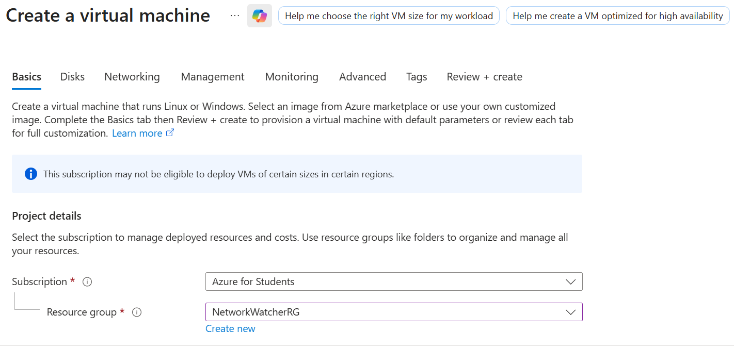
• Document VM deployment and upload screenshots to GitHub
